Source https://www.viator.com/tours/Nassau/3-hours-excursion-swimming-with-pigs-in-Nasau/d420-319857P4
__________________________________________________________

Bahamas Pig Paradise Escape: Rose Island Swim & Beach Adventure
__________________________________________________________
★★★★★ 4.7/5 20 reviews

Add to wishlist ♡

__________________________________________________________

4 hours | €215 per person

🏕  Image | 🏕  Image | 🏕  Image | 🏕  Image | 🏕  Image | 🏕  Image

__________________________________________________________
About This Tour
Step into one of the Bahamas’ most iconic experiences — swimming with the famous island pigs. This half-day escape from Nassau takes you to stunning Rose Island, where turquoise waters, white-sand beaches, and playful pigs create an unforgettable tropical adventure. Relax on the beach, paddle across crystal waters, and enjoy island vibes with lunch included.
__________________________________________________________
What’s Waiting for You
- Duration: 4 hours
- Group Size: Up to 30 travellers
- Languages: English
- Pickup: Included from Nassau hotels & Airbnbs
- Start Time: 09:00 AM
- Transport: Air-conditioned transfer + boat ride
- Season: Year-round availability
__________________________________________________________

Check Dates & Availability

Select participants: (Age 99 and younger) - 1 +

Choose date:
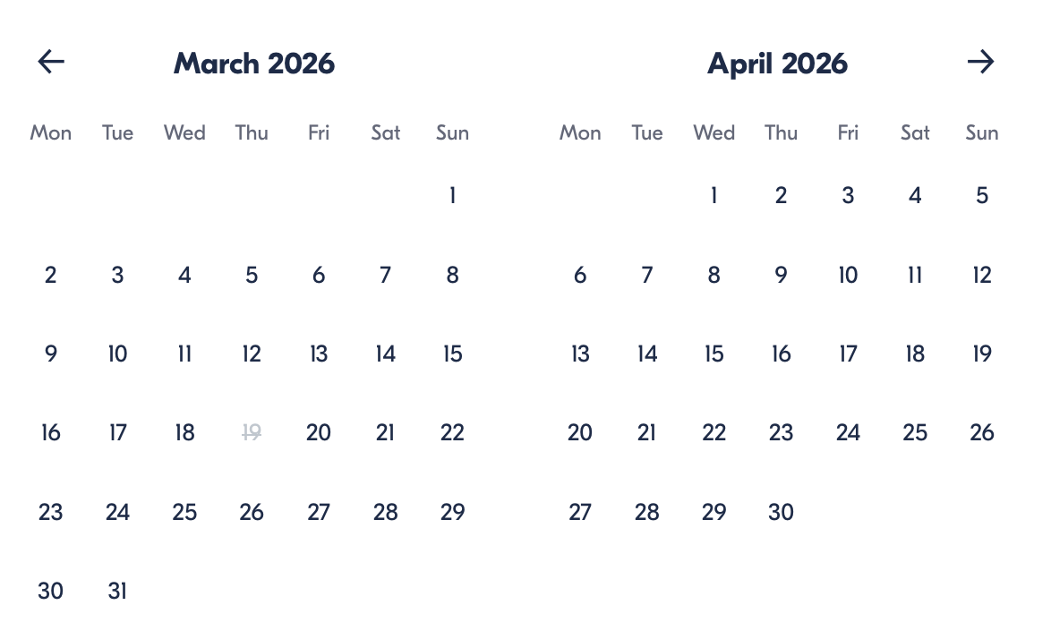

Check Availability

opens:

Participants: 1 March 16, 2026

Bahamas Pig Paradise Escape: Rose Island Swim & Beach Adventure

- Start time: 09:00 AM

Cancellation:

- More than 24 hours before start — Full refund
- Less than 24 hours — No refund

Price breakdown: 1 Participant x €215

Total: €215

The total price includes all taxes and fees.

Add to cart Book now

__________________________________________________________
Tour Features
- Swim and interact with the famous Bahamian pigs
- Relax on pristine Rose Island beaches
- Kayaks and paddleboards available
- Beach chairs and towels provided
- Lunch included
- Scenic boat ride across turquoise waters
- Fun island transfer with karaoke entertainment
__________________________________________________________
Detailed Itinerary

Island Transfer Adventure
Start your journey with hotel pickup and a lively transfer to Fort Montagu, followed by a scenic 20-minute boat ride to Rose Island.

Rose Island Beach Time
Enjoy free time to swim, sunbathe, paddleboard, kayak, or simply relax on the soft white sands surrounded by tropical beauty.

Meet the Famous Swimming Pigs
Spend about 30 minutes feeding, petting, playing with, and swimming alongside the adorable pigs — the highlight of the tour and a once-in-a-lifetime experience.

Island Lunch Break
Recharge with a delicious included lunch before heading back to Nassau.
__________________________________________________________
Included in Price
- Round-trip hotel transportation
- Boat transfer to Rose Island
- Lunch and bottled water
- Beach chairs and towels
- Kayaks and paddleboards
- Pig encounter experience
- Short island tour
__________________________________________________________
Not Included
- Tips and gratuities
- Extra snacks or drinks
- Personal purchases
__________________________________________________________
Who Should Avoid This Tour
- Wheelchair users
- Guests sensitive to boat motion
- Travellers seeking quiet/private beach environments
__________________________________________________________
Important Trip Info
Pickup times:
- Western Nassau — 9:00–9:15 AM
- Paradise Island — 9:25–9:35 AM
Accessibility: Not wheelchair accessible
Participation: Most travellers can join
Capacity: Max 30 travellers
Confirmation: Provided immediately after booking
__________________________________________________________

Cancellation Policy
- Cancel more than 24 hours before start — full refund
- Cancel within 24 hours — no refund
__________________________________________________________
What Our Clients Are Saying

Overall rating  4.7/5  ★★★★★  Based on 20 reviews | Review summary  Guide 4.5/5  Transportation 4.6/5  Service 4.7/5  Organisation 4.5/5

Filter  - All traveller types  - Couples  - Group of friends  - Families  By star rating  - All star ratings  - 5 stars  - 4 stars  - 3 stars  - 2 stars  - 1 star | Search reviews (e.g., guide)  Sort by:  - Top picks  - Latest reviews  - Best ratings  - Lowest ratings
__________________________________________________________
★★★★★
Sophia A. — United Kingdom
Swimming with the pigs was a dream! The whole trip was fun and well organised.
★★★★☆
Isabella D. — United Kingdom
Loved the pigs and beach time. The boat ride was a bit bumpy, but still worth it.
★★★★☆
Luis M. — Spain
Unique experience and great guides. Would love more vegetarian lunch options.
See more reviews
__________________________________________________________

Meta tags

Page - Bahamas Pig Paradise Escape: Rose Island Swim & Beach Adventure

Title: Bahamas Pig Paradise Escape: Rose Island Swim & Beach Adventure | Travellio Global

Description: Swim with the famous Bahamian pigs on Rose Island. Enjoy beach time, water activities, lunch, and transfers on this unforgettable half-day island adventure.

H1 - Bahamas Pig Paradise Escape: Rose Island Swim & Beach Adventure
__________________________________________________________

